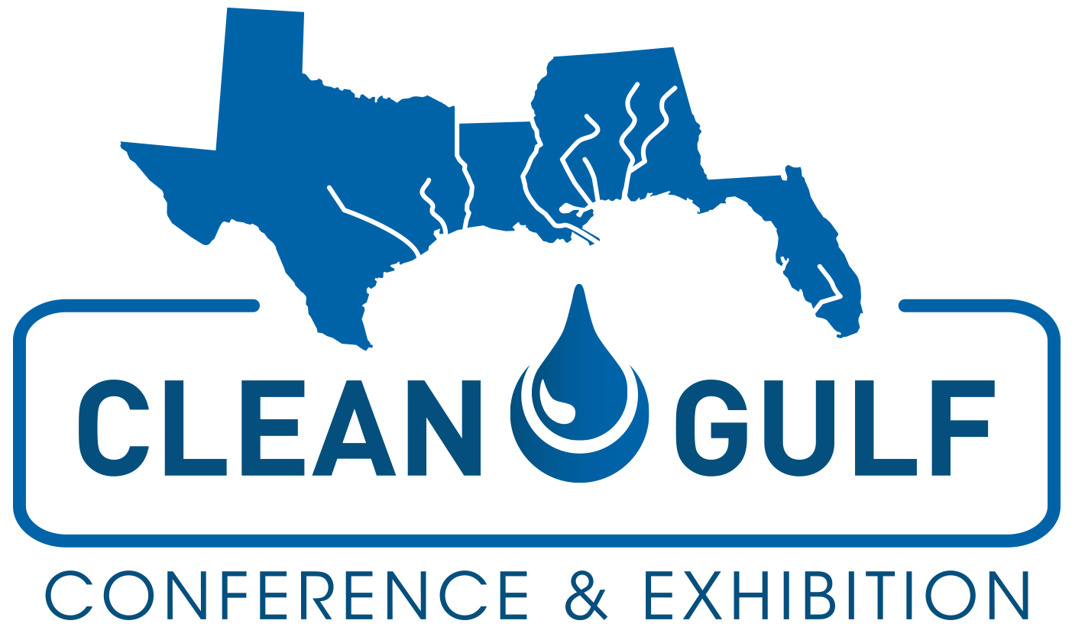

SAMPLE LETTER TO MANAGEMENT

I would like to register to attend CLEAN GULF 2023. The conference will be held November 7-9 at the Henry B. Gonzalez Convention Center in San Antonio, TX.

CLEAN GULF offers a variety of sessions, as well as exhibiting companies, focused on real-world solutions for environmental emergencies. I will be able to attend sessions that directly apply to my ongoing projects at this organization and visit with numerous companies who can provide solutions catered to our unique needs.

The conference sessions are led by well-known industry and government experts and will offer tips & strategies that I can implement upon my return. A few sessions that I am particularly interested in include <insert session titles.> I would like to attend these because I feel I will gain <insert learning objectives> and be able to implement the findings in <insert projects or departments that will benefit.>

This conference will enable me to build relationships with attendees from oil & gas, maritime, rail, environmental, regulatory agencies, oil spill response organizations and service companies and learn from their experiences. The information I take away from this conference, as well as the contacts I make, will be invaluable for future endeavors at our company.

The CLEAN GULF exhibit hall will feature 100+ companies who can provide products and solutions to improve our environmental emergency prevention, response and recovery efforts. I will have the opportunity to meet with many of these companies, virtually eliminating the time and cost of separate future trips to each company.

By registering early, I can save on registration by receiving a discounted rate. Additionally, if multiple people from the company register at the same time, we can receive even deeper discounts. I am asking for funding for the conference fee, travel costs, food and lodging.

CLEAN GULF has arranged for hotel and airfare discounts. In addition, the full conference registration includes 2 days of lunch, networking reception(s) and access to online conference proceedings.

I feel that attending CLEAN GULF is a valuable experience that would greatly benefit my performance at this organization. I will be able to bring home all conference materials, allowing me to share with others in the office and possibly train them if needed.
Thank you for considering this proposal. Please let me know if there is any additional information I can provide to help make your decision.

